OPERATING SYSTEMS
WEEK-4 Practical
Name:- G.Sahasra
Roll no:- 2520030108
Section no:- 9
1Q. Write a C program where a parent process creates multiple child processes and synchronizes their completion using wait() and waitpid(). Compare the behavior of both functions. Create a scenario where a child process becomes a zombie process. Investigate the process table and then modify the program to eliminate zombie processes using proper synchronization techniques.
Program:-
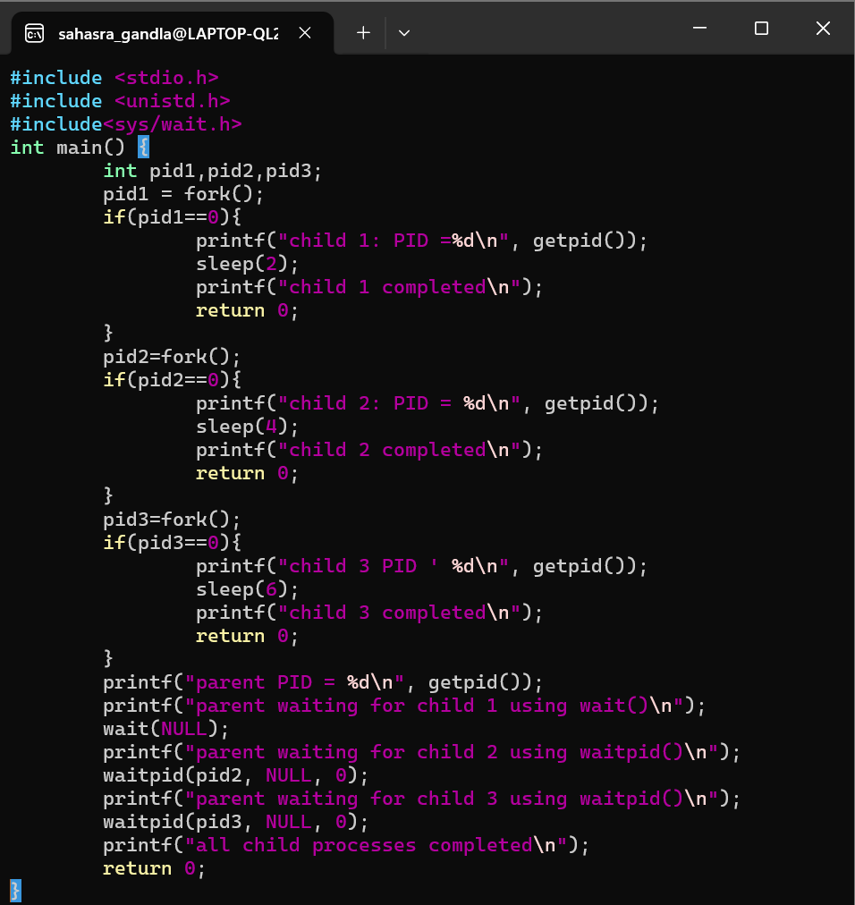

Output:-
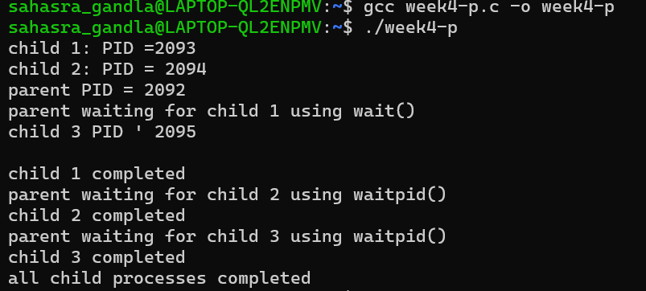
Program:
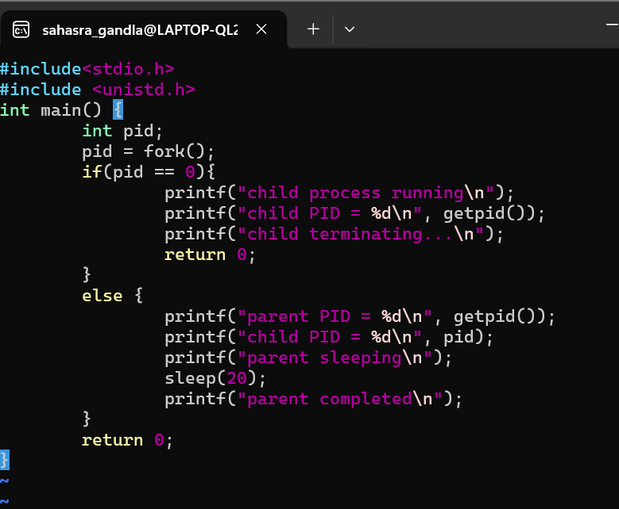

Output:
